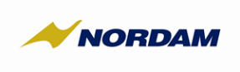 | Hazard Report Form | FR-TNG-QA-02  (Rev. IR) May 7, 2026

This form may be completed to report any noted condition, event or circumstance that has the potential to affect the safety of components, equipment, structures or personnel when fitted to aircraft.
NORDAM maintains a Safety Management System (SMS) that meets the requirements of Appendix 2 to ICAO Annex 19. The information contained in Hazard Reports is reviewed and processed in accordance with NORDAM Safety Risk Management Processes. All information will be treated as confidential and will be used to improve the safety of NORDAM’s services to its customers.
Name: | Date:
Location of Occurrence: | Date of Occurrence:
Equipment:
Description of Hazard: (include actions taken, if any, to correct the issue)
Signature:
Please email completed form to icolon@nordam.com

